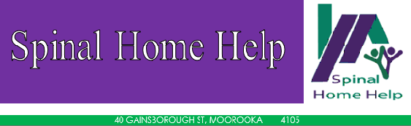

Membership Application Membership Renewal DATE: ___/___/___

Spinal Home Help - MEMBERSHIP FORM

Section 1: Personal and Contact Details

Membership # (if applicable):_____________________ Title:____________________
First Name:__________________________ Last Name:__________________________
Company/Organisation (if applicable):_________________________________________
Residential Address:
____________________________________________________ Post Code___________
Mailing Address (if different from Residential Address):
____________________________________________________ Post Code___________
Telephone:____________________________ Mobile:____________________________
Email:___________________________________________________________________

Section 2: Membership Types

Please select type (): | Eligibility: | Benefits:
Ordinary Member  $20/yearly subscription | At least 18 years of age  Must have a spinal cord injury or disability due to spinal cord injury, acquired either by accident or disease (including polio)  OR a parent, spouse, sibling or child of an individual with a spinal cord injury | Eligible to vote at AGMs  Free attendance to SHH workshops and info sessions  Access to SHH Referral Service  Spinal Home Help Newsletter  Members-only events
Junior Member  $10/yearly subscription | Under 18 years of age at the time of applying  Must have a spinal cord injury or disability due to spinal cord injury, acquired either by accident or disease (including polio)  Consent of parent or guardian | Free attendance to SHH workshops and info sessions  Access to SHH Referral Service  Spinal Home Help Newsletter  Members-only events
Associate Member  $20/yearly subscription | Anyone is eligible | Free attendance to SHH workshops and info sessions  Spinal Home Help Newsletter  Members-only events
Organisation Membership  $50/yearly subscription | Any business, corporation, community organisation or incorporated entity committed to supporting people with spinal cord injury and their families | 3 speaking sessions/seminars for your organisation per year (peer mentors, spinal injury safety, accessibility advice)  Spinal Home Help Newsletter  Partnership opportunities
*Spinal Help has Public Liability Insurance of $20 000 000
**Membership Renewals due by 30th June each year

Section 3: Declaration and Disclosure

Declaration by Applicant:
I (signature of applicant) ____________________________________________________ certify that the information given by me is correct and hereby make application for membership of Spinal Home Help Incorporated. I agree to be bound by and act in accordance with, the respective constitution, by-laws, rules, policies and procedures of Spinal Home Help Inc.
I hereby consent to the collection and use of my images for the purposes of promoting Spinal Home Help in marketing materials and on social media, website, newsletter and publications. I understand that these images can be viewed by anyone who accesses Spinal Home Help media, website and materials, and I understand that my consent can be withdrawn at any time, upon written notice to the Secretary.

Your privacy is our priority. All personal information you have provided will assist us to process your membership application and to communicate with you regarding our services, activities and events. You can access your information record to verify its accuracy if you are concerned. We will not disclose the identified information to anyone without your permission unless required by law.

NAME AND SIGNATURE OF PARENT OR GUARDIAN IF APPLICANT IS UNDER 18
NAME (print) _________________________SIGNATURE _______________________

Section 4: Payment
METHOD OF PAYMENT:

Direct Deposit
Name: SHH Operations Account BSB: 064-118 Account: 10489174
*please quote ‘Member’ and the date as payment reference

Cheque – Payable to “Spinal Home Help Incorporated’

Office Use Only – Payment Processed:___________ __/__/____

